

# ****Setting up the Den:****

**[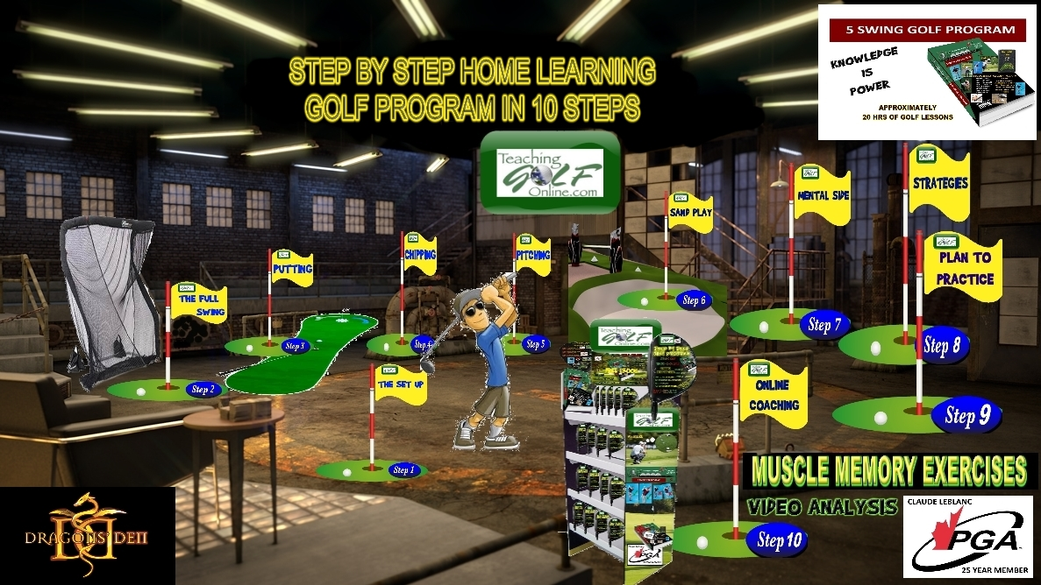](http://www.teachinggolfonline.com/wp-content/uploads/2018/04/den6.jpg)**

# ****Presenting my business to the Dragons****



1. **Hello Dragons:**

* **My name is Claude LeBlanc;**
* **I come from Campbellton, New Brunswick;**
* **I am a school teacher and a teaching golf professional; and**
* **I am a 25-year member of the PGA of Canada.**

**I’m here to ask you for $50,000 in exchange for 10% of my business.**

**[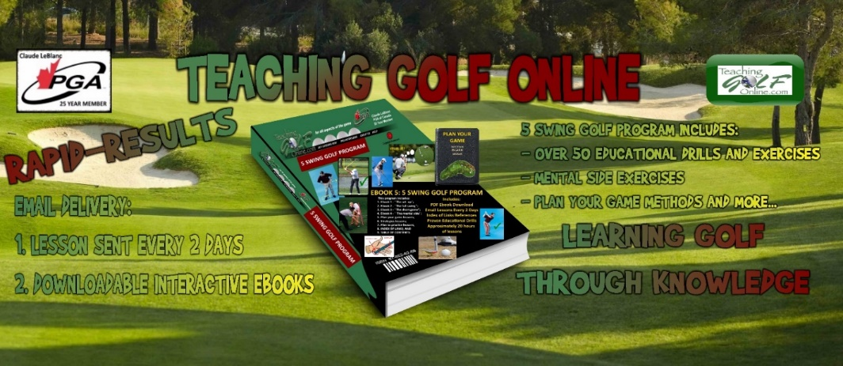](http://www.teachinggolfonline.com/wp-content/uploads/2018/02/HEADERPAINT5AXZ3.gif)**

**2) MY BUSINESS REFLEX MY WEBSITE NAME:**

**TEACHING GOLF ONLINE.COM IS A STEP BY STEP HOME LEARNING GOLF PROGRAM.**

**IT INCLUDES THE FOLLOWING:**

1. **Access to interactive ebooks that covers the entire program;**
2. **Golf lessons sent via email delivery to your inbox every 2 days; and**
3. **Accessible on all devices (computer, phone and tablets).**



**3) WHAT IS THE “5 SWING GOLF PROGRAM”?**

**[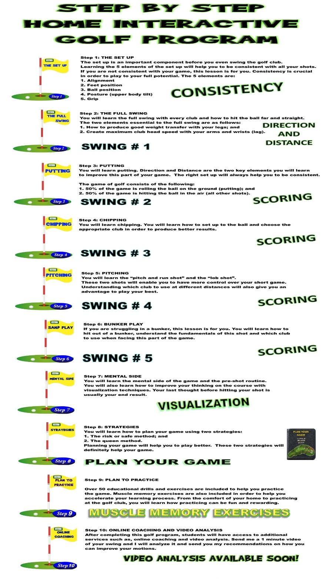](http://www.teachinggolfonline.com/wp-content/uploads/2018/03/ALLSTEPS4-75A.jpg)**

1. **Three different topics with CONSISTENCY being a priority, will be presented to the DRAGONS. These three topics will definitely improve the skills of any golfer, at any level. I will try to cover as much as possible with the time allotted.                         TOTAL: ? MINUTES**
2. **The set up: I will focus primarily on POSTURE. This will help with CONSISTENCY;**
3. **The full swing: Maintain the PROPER POSTURE for CONSISTENCY (Swing #1); and**
4. **Putting: DISTANCE, DIRECTION AND CONSISTENCY (Swing #2).**

**LESSON 1:**

[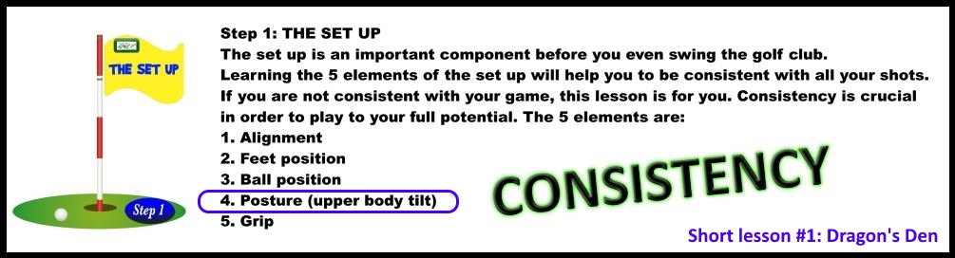](http://www.teachinggolfonline.com/wp-content/uploads/2018/04/lesson-1.jpg)

**Step 1: THE SET UP**

**People actually do not realize how important it is to set up properly and maintain a good posture during the 3 phases of the full swing. This will able the golfer to achieve CONSISTENCY.**

**There are 5 elements to the set up:**

1. **Alignment**
2. **Feet position**
3. **Ball position**
4. **Posture (upper body tilt) = CONSISTENCY**
5. **Grip**

**DRAGONS PARTICIPATION:**

**Working with Dragons on the POSTURE DRILL.**

**LESSON 2:**

[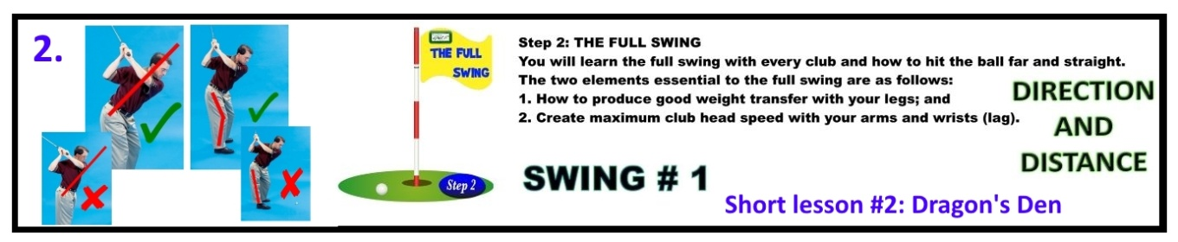](http://www.teachinggolfonline.com/wp-content/uploads/2018/04/lesson-2cccf.jpg)

**When learning the full swing, you will be directed to do the following:**

* **Maintain the proper posture of the set up for CONSISTENCY.**
* **Changing angles with your POSTURE during the swing will change the direction of your shot. In order to achieve CONSISTENCY, the POSTURE must be maintained during the 3 phases of your swing:**

**Phase 1: Backswing  
Phase 2: Downswing  
Phase 3: Follow through**



## ****I WILL EXPLAIN THE USE OF THE MUSCLE MEMORY EXERCISES IN ORDER TO ACCELERATE YOUR LEARNING PROCESS.****

**THIS INFORMATION CAN BE FOUND AT TEACHING GOLF ONLINE.COM.**

**DRAGONS PARTICIPATION:**

**Working with Dragons on the WEIGHT TRANSFER DRILL and (MUSCLE MEMORY EXERCISES).**

**WHAT IS GOLF?**

[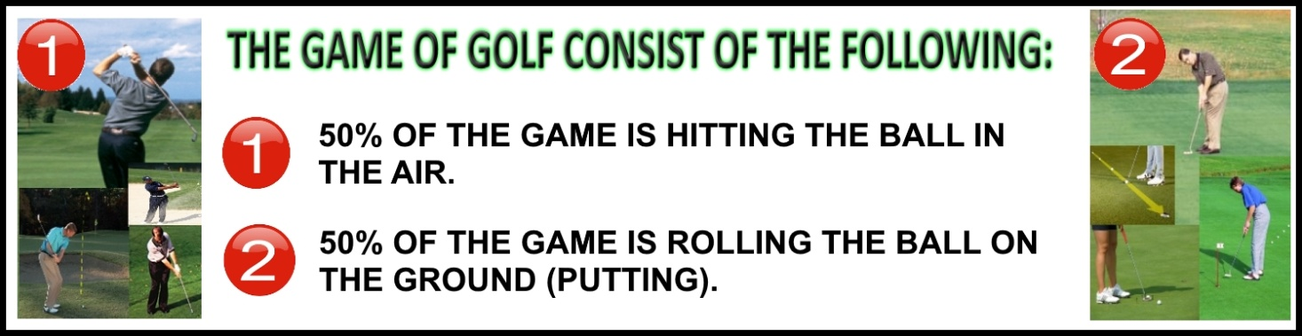](http://www.teachinggolfonline.com/wp-content/uploads/2018/04/50X50A.jpg)

**LESSON 3:**

**Putting– DISTANCE and DIRECTION (Swing #2)**

* **The proper set up when putting will create CONSISTENCY.**

[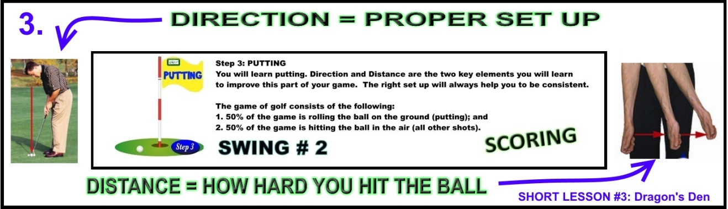](http://www.teachinggolfonline.com/wp-content/uploads/2018/04/DIRECTIONANDDISTANCE3A.jpg)

**DRAGONS PARTICIPATION:**

**Working with Dragons on the DISTANCE DRILL.**

**5) WHY ARE PEOPLE NOT TAKING GOLF LESSONS?**

**I notice golfers spending hundreds, sometimes thousands of dollars on equipment yet we rarely see them taking lessons or even practicing.**

**According to research, only 13% of golfers (of any ability) take golf lessons. How come?**

**Here are 4 reasons according to research:**

1. **Golfers are worried about having their techniques criticized.**
2. **No time, busy at work.**
3. **Golf lessons are too expensive.**
4. **Afraid and or intimidated of taking golf lessons from Golf Professionals.**

**6) PURCHASING THE PROGRAM:**

**When the program is purchased, the customer receives the following:**

1. **PDF Interactive ebooks available to view on any electronic device, (computer, phone or tablet) with links to additional information.**
2. **Lessons sent by email delivery to your inbox every 2 days.**
3. **Approximately 20 hours of golf lessons.**



# ****7) PURCHASE A GIFT FOR A FRIEND ONLINE:****

## ****This gift of golf called ”5 SWING GOLF PROGRAM” will be sent, by email delivery, to a friend on your behalf.****



**8) PURCHASE THE STEP BY STEP HOME GOLF PROGRAM AT CANADIAN TIRE OR WALMART:**

**An access gift card has an inside code, in order to activate the golf lesson program online.**

* **WHY NOT BUY GOLF LESSONS AT CANADIAN TIRE, WALMART OR OTHER SPORTING STORES?**
* **(MORE PEOPLE WOULD LEARN = MORE PEOPLE WOULD PLAY = MORE PEOPLE WOULD PURCHASE = MORE REVENUES FOR ALL CLUBS).**
* **WIN WIN SITUATION ALL THE WAY AROUND.**

[](http://www.teachinggolfonline.com/wp-content/uploads/2018/03/DISPLAY-ADD-TGO-PNG2.png)

[](http://www.teachinggolfonline.com/wp-content/uploads/2018/03/ACCESS-CODE-GIFT-CARD4.png)





My association, being the PGA of Canada, are very interested in supporting me, any way possible. Will talk to you soon.

Thank you.



## ****Claude LeBlanc**** ****PGA of Canada (25 - year member)**** ****Teaching Golf Professional****